

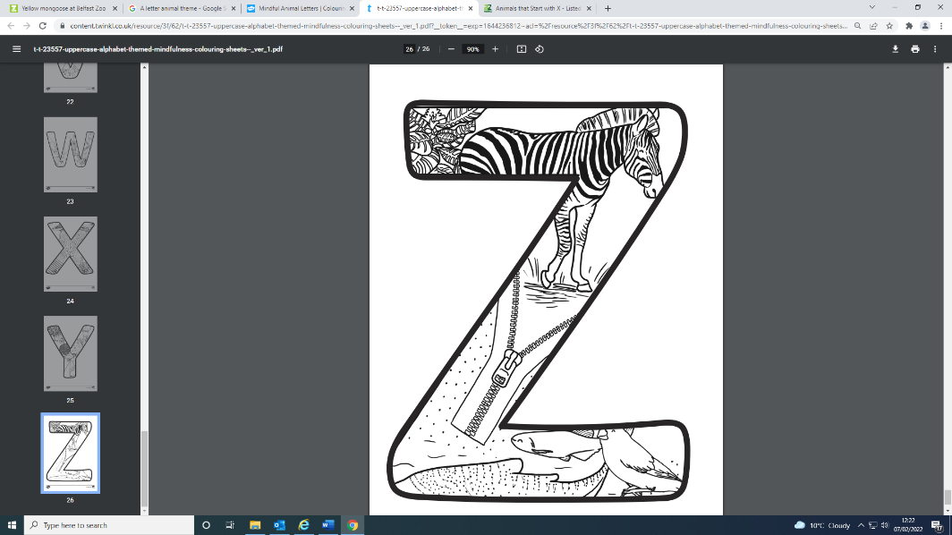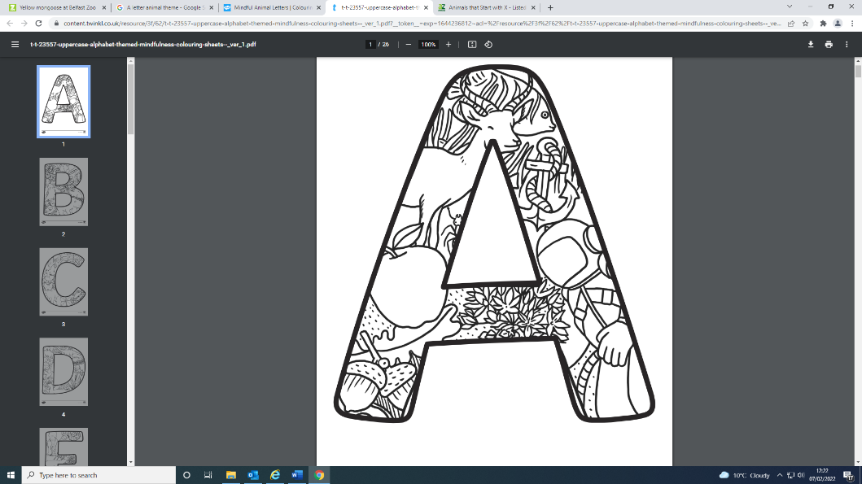

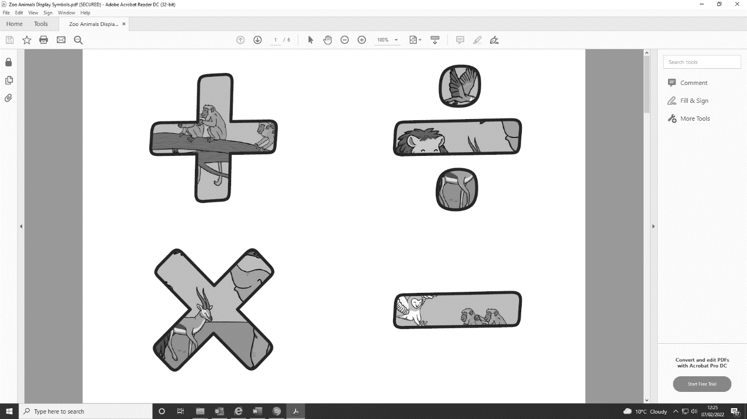

Colouring in book

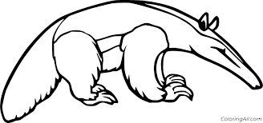Aa

*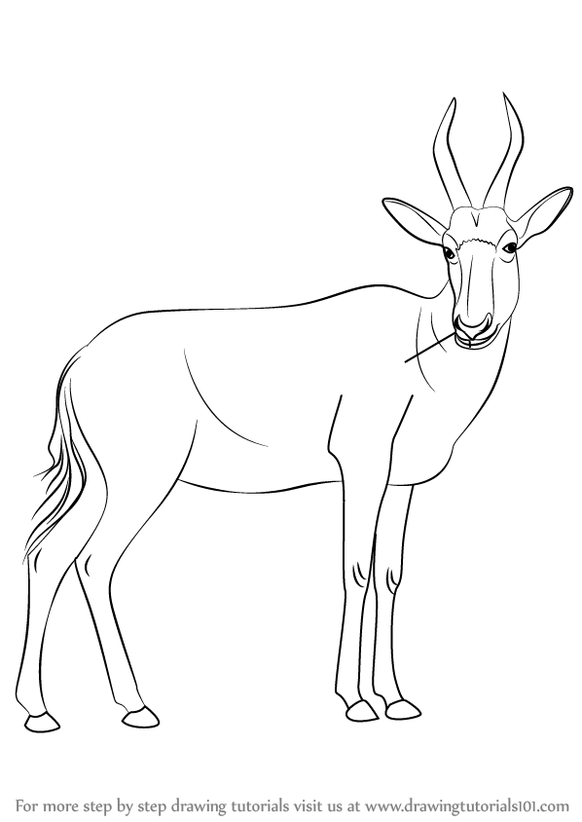*

Aa is for *anteater*

Bb

*Bb is for blesbok*

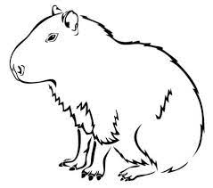Cc

*Cc is for Capybara*

*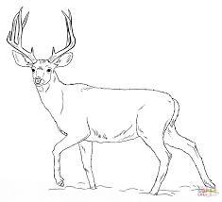*Dd

*Dd is for Deer*

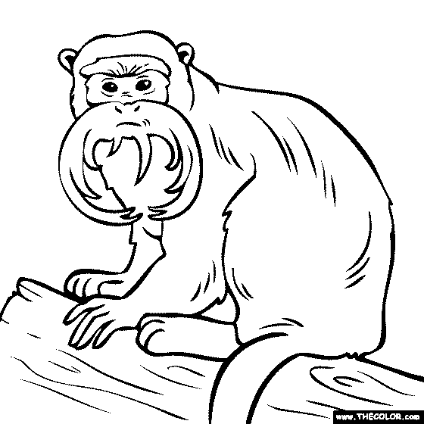Ee

*Ee is for Emperor tamarin*

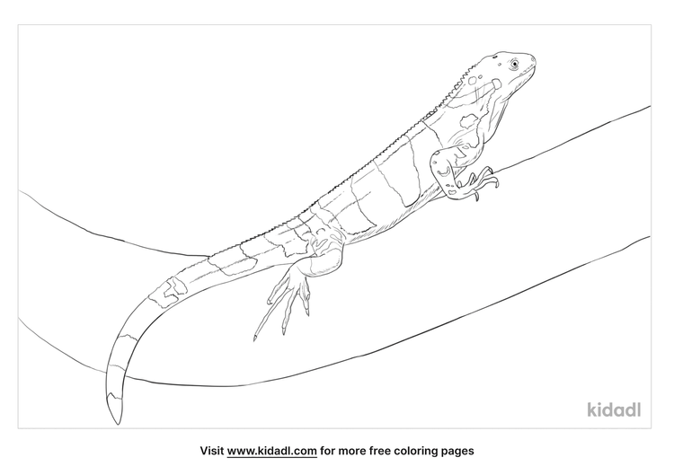Ff

*Ff is for*

*Fiji banded iguana*

*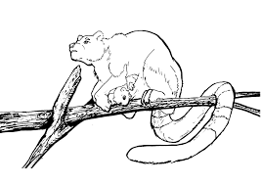Gg*

*Gg is for* *Goodfellow’s tree kangaroo*

*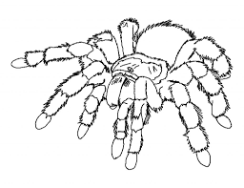Hh*

*Hh is for Honduran curly haired tarantula*

*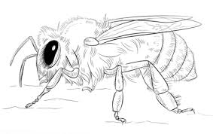Ii*

*Ii is for Irish black honeybee*

*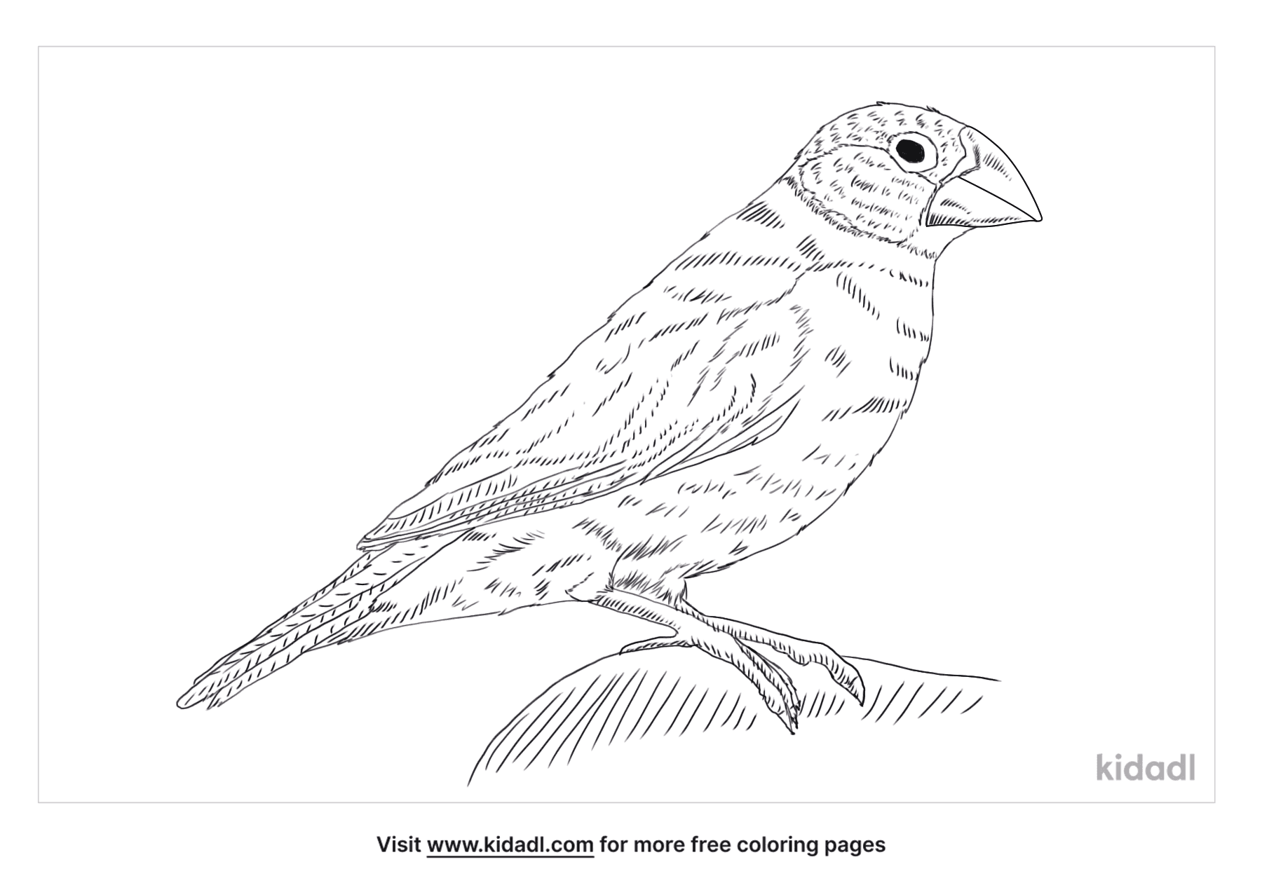Jj*

*Jj is for Java sparrow*

*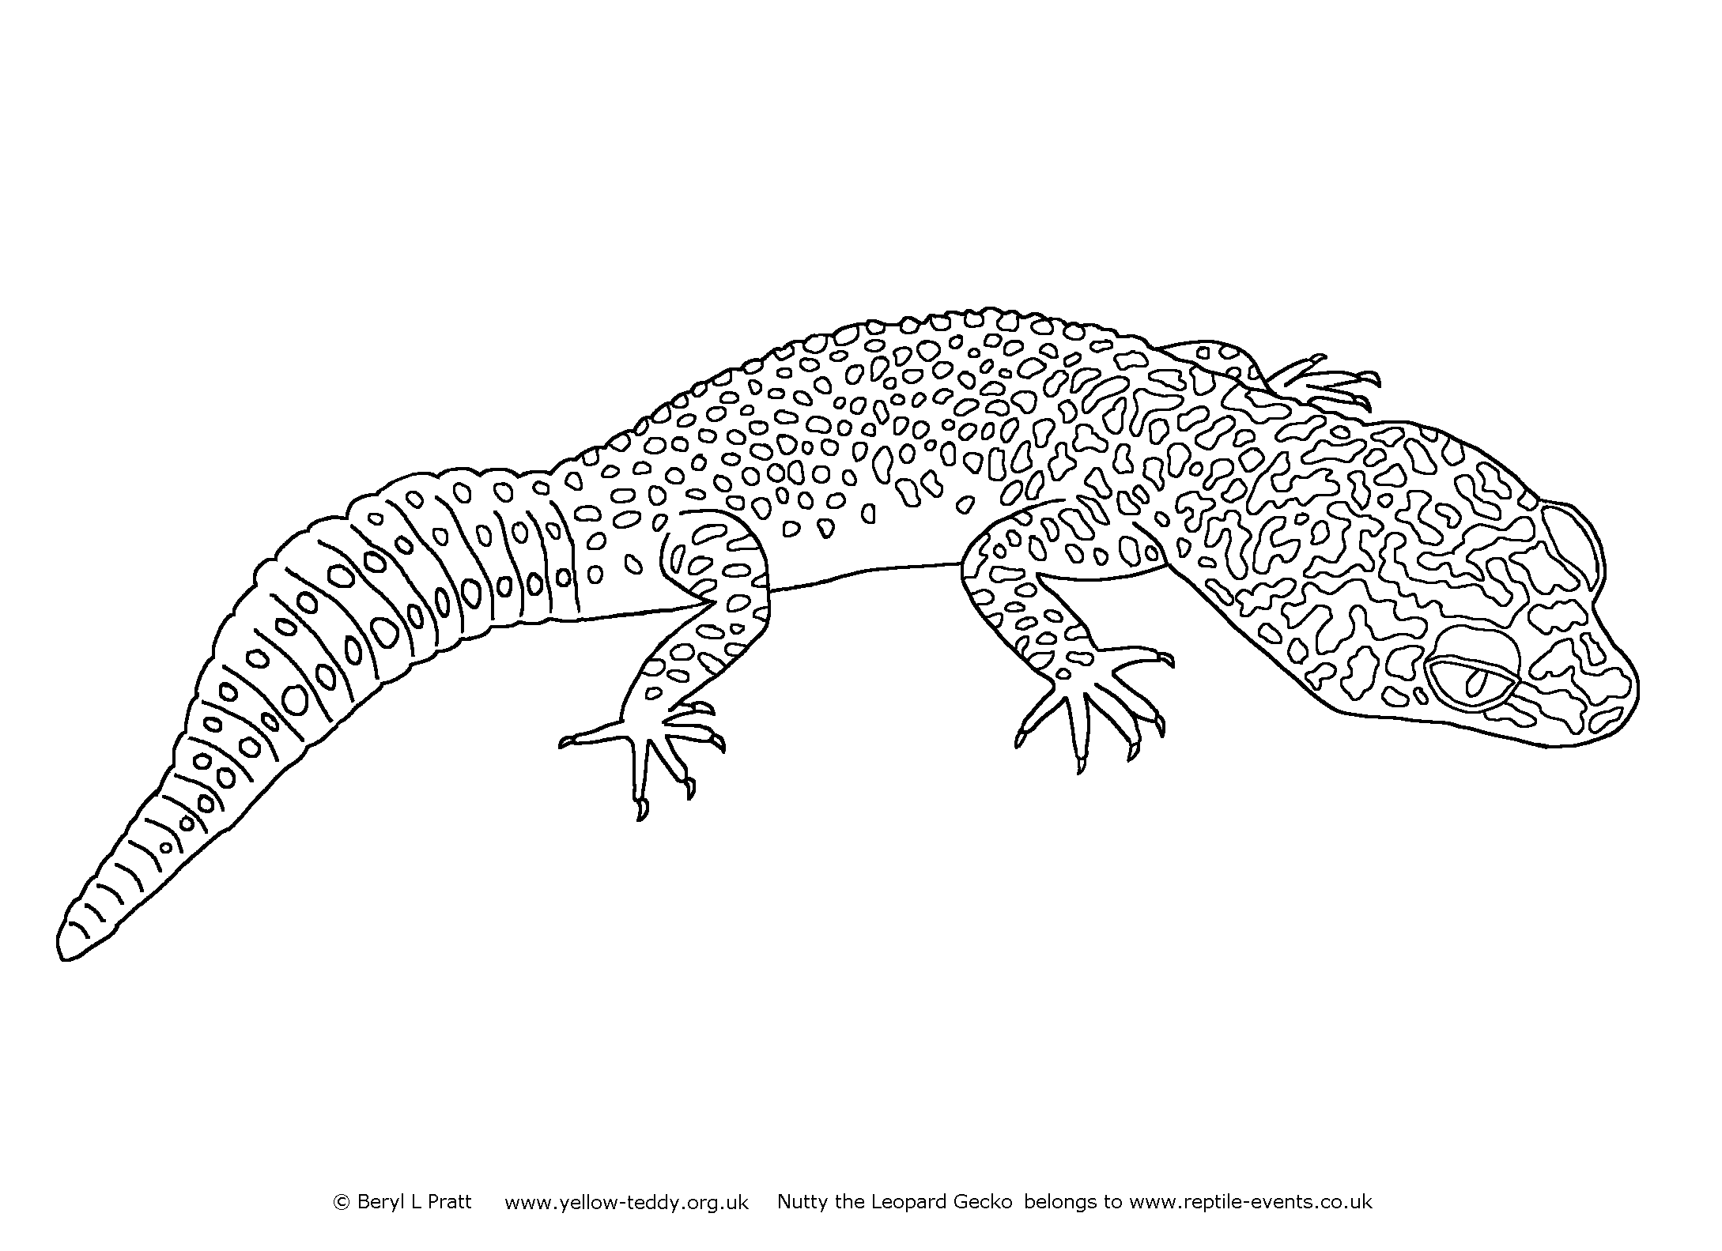Ll*

*Ll is for Leopard gecko*

*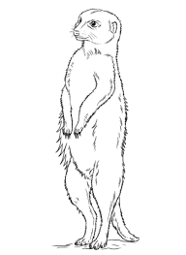Mm*

*Mm is for Meerkat*

*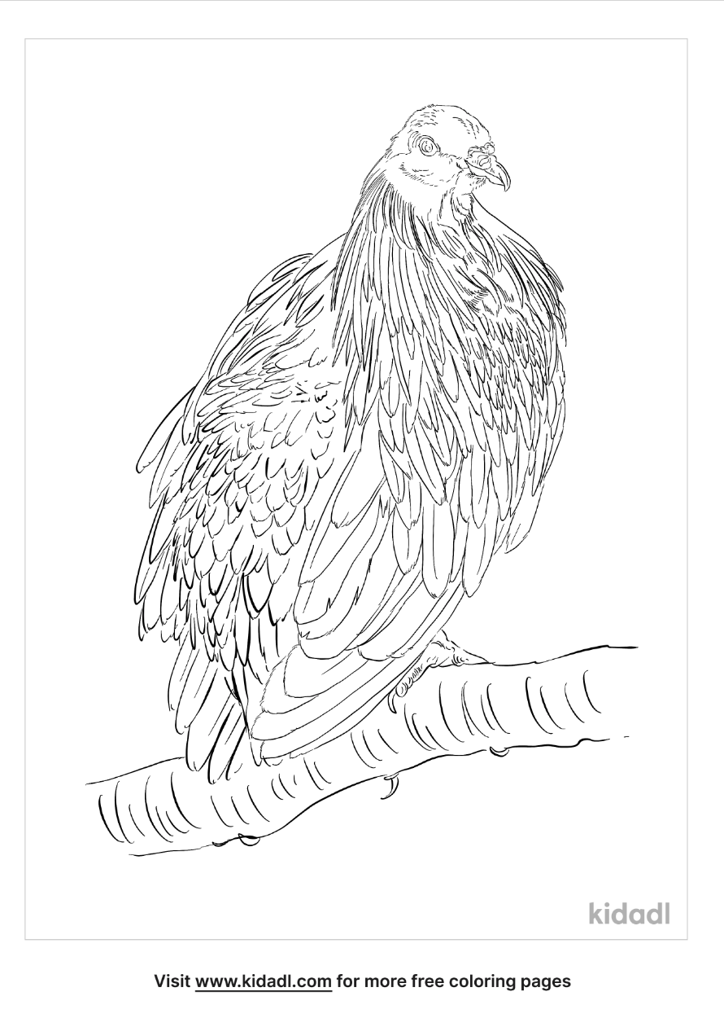Nn*

*Nn is for Nicobar pigeon*

*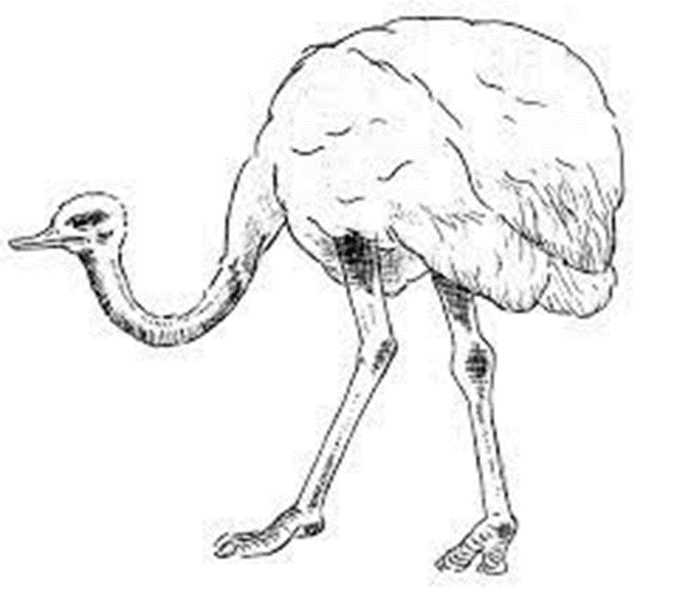Oo*

*Oo is for Ostrich*

*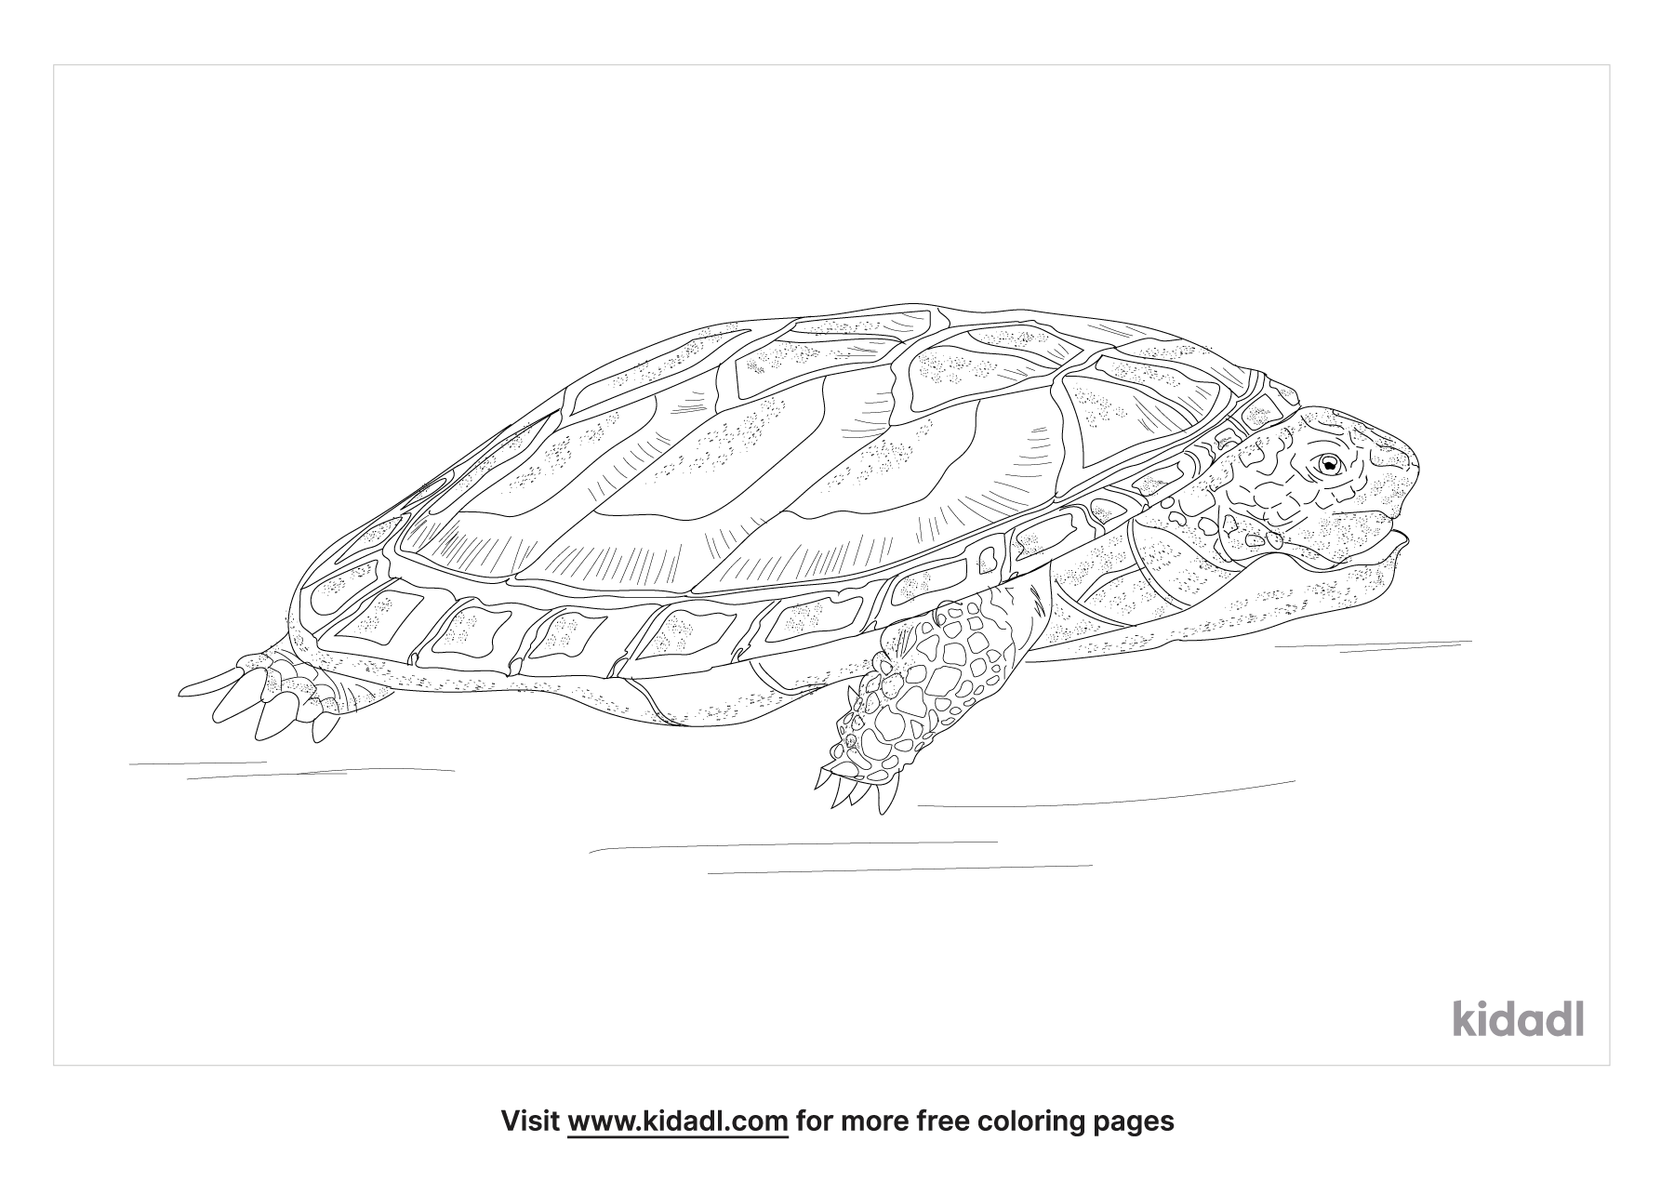Pp*

*Pp is for Pancake tortoise*

*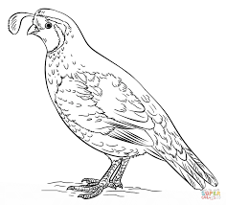*

*Qq*

*Qq is for* *Quail*

*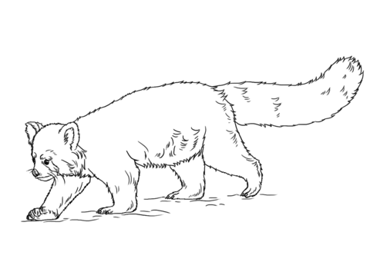Rr*

*Rr is for Red panda*

*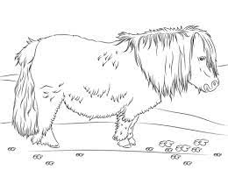Ss*

*Ss is for Shetland pony*

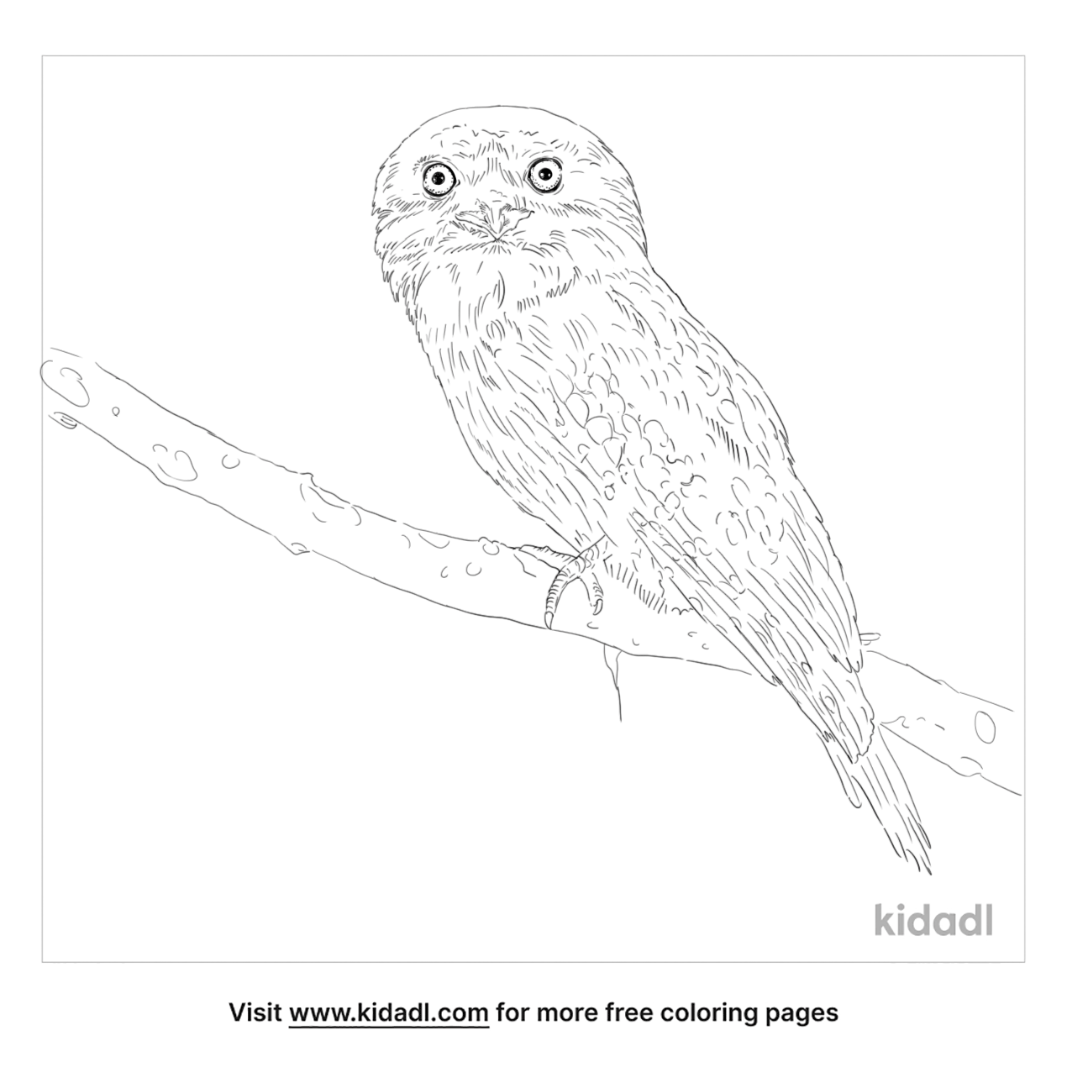*Tt*

*Tt is for Tawny frogmouth*

*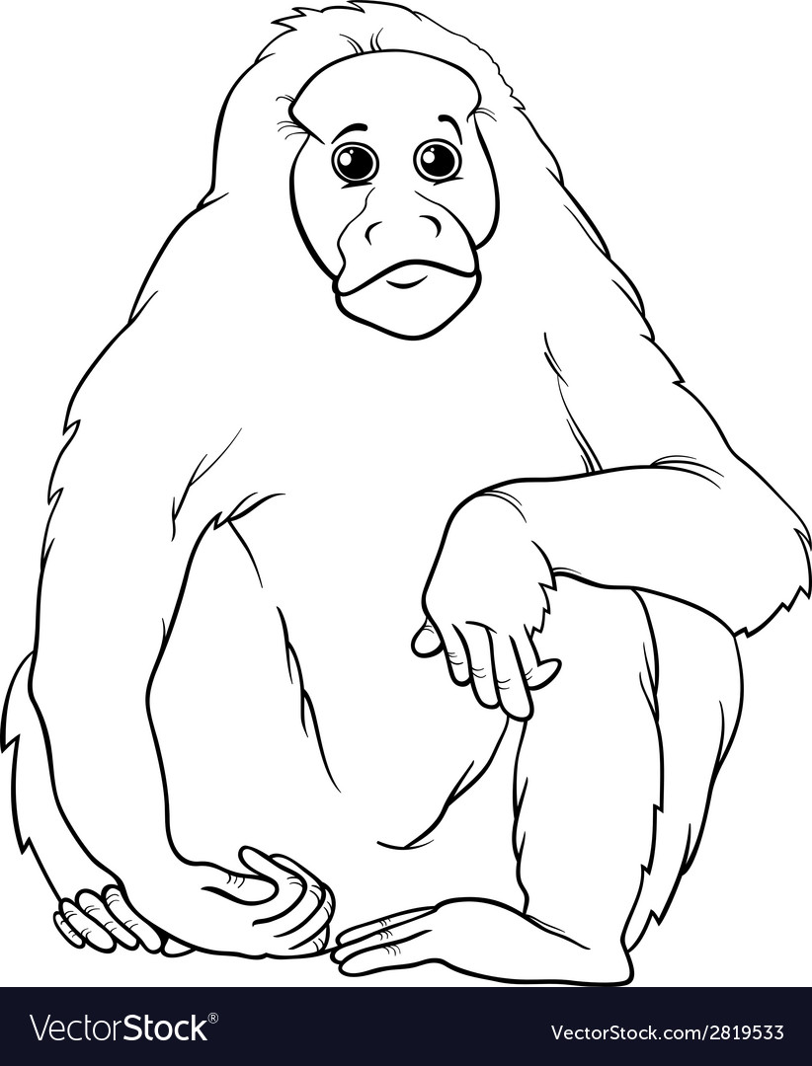Uu*

*Uu is for Uakari*

*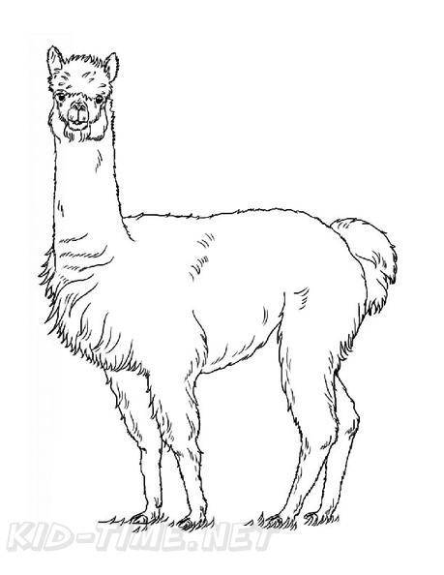Vv*

*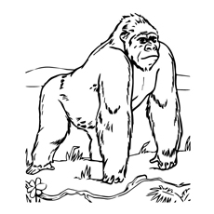Vv is for Vicuña*

*Ww*

*Ww is for Western lowland gorilla*

*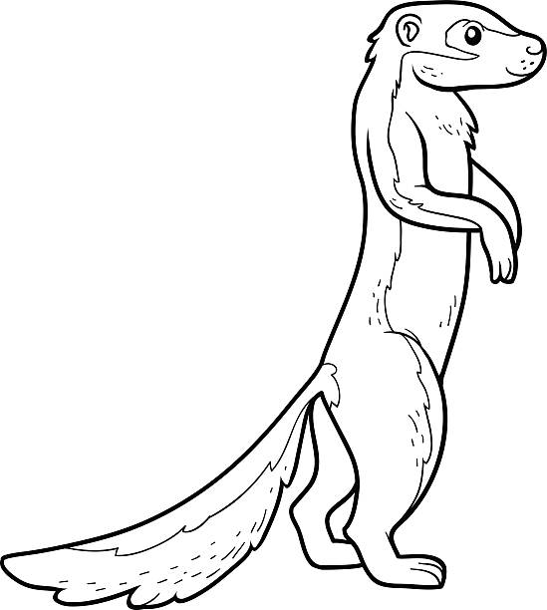*

*Xx*

*Xx is for Xerus*

*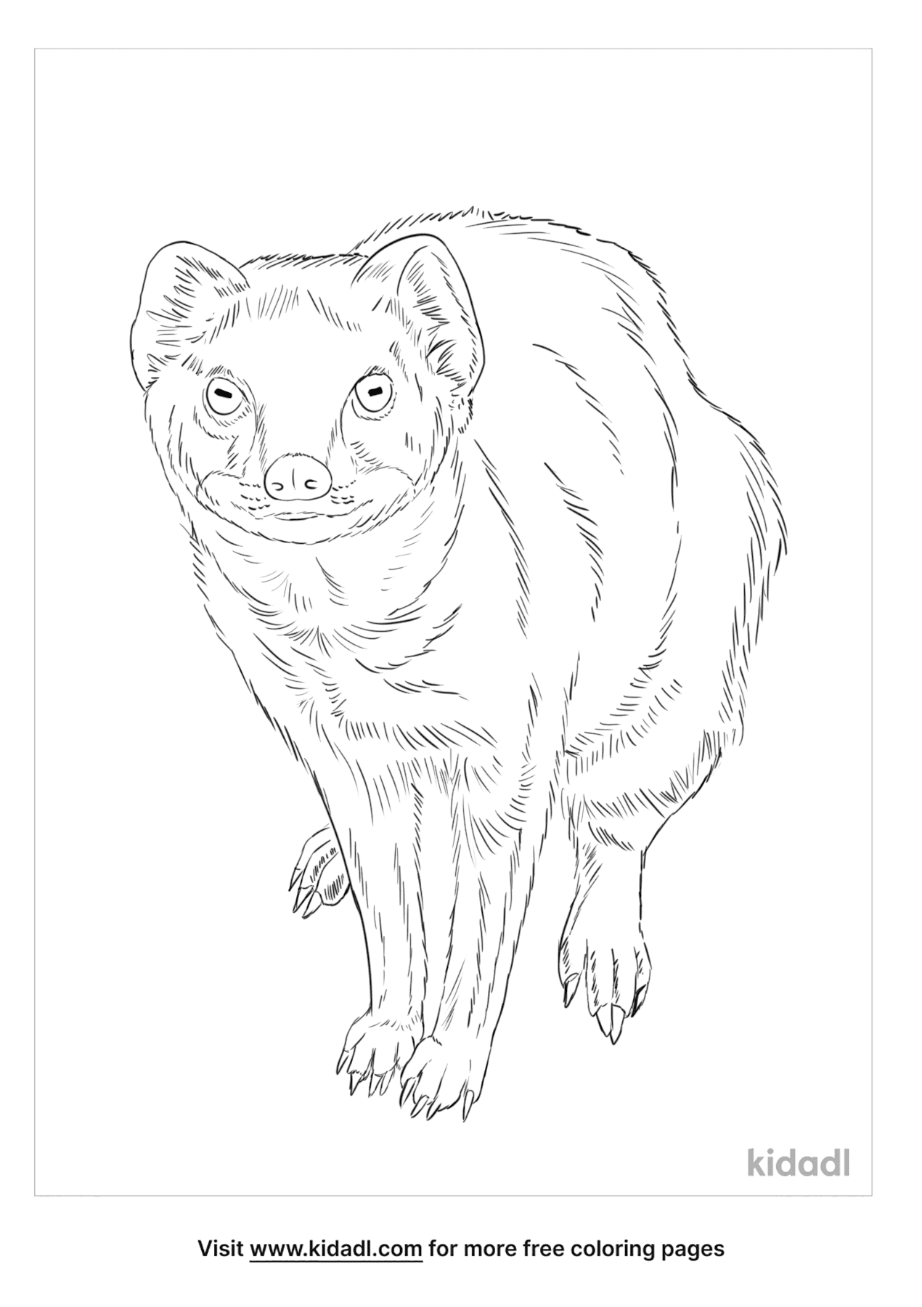Yy*

*Yy is for Yellow mongoose*

*Zz*

*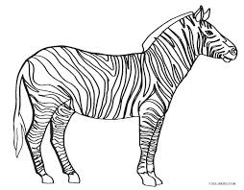Zz is for Zebra*